Generating synthetic data from SQL databases or Excel files using Generative Adversarial Networks (GANs) involves several critical steps. Below, I’ll provide a comprehensive overview of the process using the **Conditional GAN (CGAN)** as an example, since CGANs are effective for generating synthetic data conditioned on specific attributes or labels.

**Overview of Conditional GAN (CGAN)**

**CGANs** extend the basic GAN framework by conditioning the data generation process on specific information (like class labels). This is particularly useful when we want to generate data that resembles certain features or characteristics of the original dataset.

**Steps for Synthetic Data Generation Using CGAN**

**1. Data Collection**

**Description**: Gather the dataset you want to use for training the GAN. This could be from an SQL database or an Excel file.

**Example**: Suppose you have a dataset of customer transactions stored in an SQL database with the following columns:

* CustomerID
* Age
* Gender
* Income
* TransactionAmount

**Importance**: The quality and representativeness of the dataset directly impact the synthetic data generated. A diverse and comprehensive dataset will help the CGAN learn meaningful patterns.

**2. Data Preprocessing**

**Description**: Clean and preprocess the data to ensure it’s suitable for the model. This includes handling missing values, normalizing numerical features, and encoding categorical features.

**Steps**:

* **Remove Duplicates**: Ensure there are no duplicate rows.
* **Handle Missing Values**: Use imputation or removal strategies to deal with missing data.
* **Normalization**: Scale numerical features to a common range (e.g., 0 to 1) to enhance training stability.
* **Encoding Categorical Features**: Convert categorical variables into numerical formats (e.g., using one-hot encoding or label encoding).

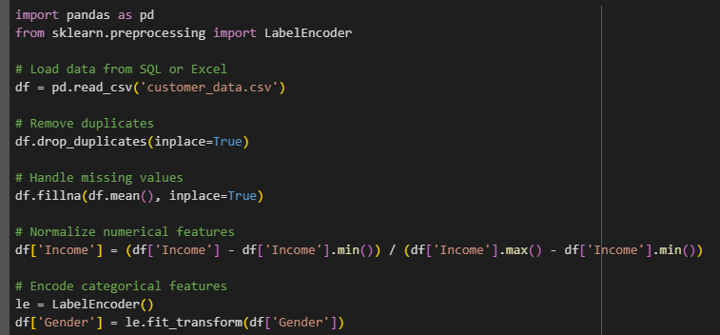

**Importance**: Preprocessing ensures the data is clean and in a format suitable for training, which reduces noise and enhances the model's ability to learn.

**3. Split the Data**

**Description**: Divide the dataset into training and testing sets. The training set will be used to train the CGAN, while the testing set will help evaluate the model.

**Example**:

**Importance**: A proper split helps assess the model's performance on unseen data, ensuring that the synthetic data generated is representative of the original dataset.

**4. Define the CGAN Architecture**

**Description**: Build the generator and discriminator networks. The generator creates synthetic data, while the discriminator evaluates its authenticity.

**Generator**: Takes random noise and conditional input (e.g., class labels) to produce synthetic data. **Discriminator**: Takes both real and synthetic data and tries to distinguish between them.

**Example**:

**Importance**: The architecture determines how well the CGAN can learn and generate synthetic data. Proper design choices are essential for effective learning.

**5. Train the CGAN**

**Description**: Train the generator and discriminator in an alternating fashion. The generator learns to produce more realistic data, while the discriminator becomes better at distinguishing real from synthetic data.

**Steps**:

1. Sample random noise and corresponding labels for training.
2. Generate synthetic data using the generator.
3. Compute the discriminator's loss on real and synthetic data.
4. Update the discriminator's weights.
5. Generate new noise and labels for the generator.
6. Compute the generator's loss based on the discriminator's feedback.
7. Update the generator's weights.

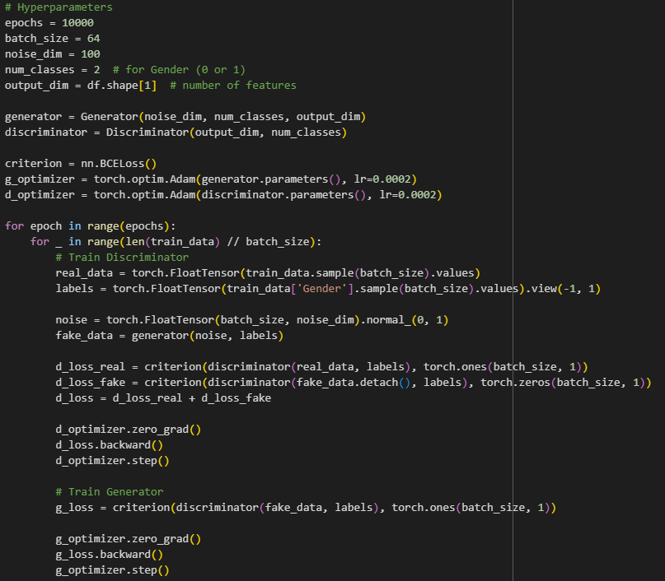

**Importance**: Training the CGAN involves a careful balance between the generator and discriminator. If one outperforms the other too much, it can lead to poor synthetic data quality or mode collapse, where the generator produces limited diversity.

**6. Generate Synthetic Data**

**Description**: After training, use the generator to create new synthetic data.

**Example**:

**Importance**: Generating synthetic data allows you to create diverse datasets without compromising privacy, making it useful for testing, training models, or augmenting existing datasets.

**7. Post-Processing**

**Description**: After generating synthetic data, perform any necessary post-processing to ensure it meets your requirements (e.g., rounding, scaling back).

**Example**:



**Importance**: Post-processing helps ensure the synthetic data is in a usable format and adheres to any required specifications or constraints.

**8. Evaluation of Synthetic Data**

**Description**: Evaluate the quality of the synthetic data by comparing it to the original dataset. This can involve statistical tests, visualizations, and domain-specific metrics.

**Example**:

**Importance**: Evaluating the synthetic data ensures that it retains the properties of the original dataset, making it useful for real-world applications. This step helps identify any discrepancies that may affect model performance or validity.